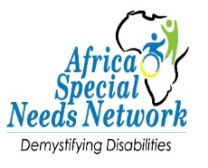
ASNEN Annual Report 2024

Table of Contents
- Executive Summary
- Introduction
- Key Highlights of 2024
  - Webinars and Educational Initiatives
  - Workshops and Advocacy Efforts
  - Collaborations and Partnerships
- Community Impact
- Challenges Faced
- Financial Overview
- Looking Ahead: 2025 Goals
- Appendices

Executive Summary
In 2024, the Africa Special Needs Education Network (ASNEN) achieved significant milestones in its mission to enhance the inclusion and support of neurodivergent individuals and those with disabilities. Through a diverse array of initiatives, including webinars, workshops, and community outreach, ASNEN impacted hundreds of lives, strengthened its advocacy efforts, and laid the groundwork for future success.
Highlights include:
- 9 Webinars, with over seven hundred participants collectively, addressing topics ranging from neurodiversity to financial planning for neurodivergent children.
- Participation in key workshops, such as the 2023-2027 National Education Sector Strategic Plan (NESSP) APHRC Workshop, Project Launch: Localizing Women’s Empowerment and Childcare in Kenya and Foetal Alcohol Spectrum Disorder (FASD)
- Community outreach initiatives like the Malaika Disability Walk and surgeries for children with correctable physical disabilities. 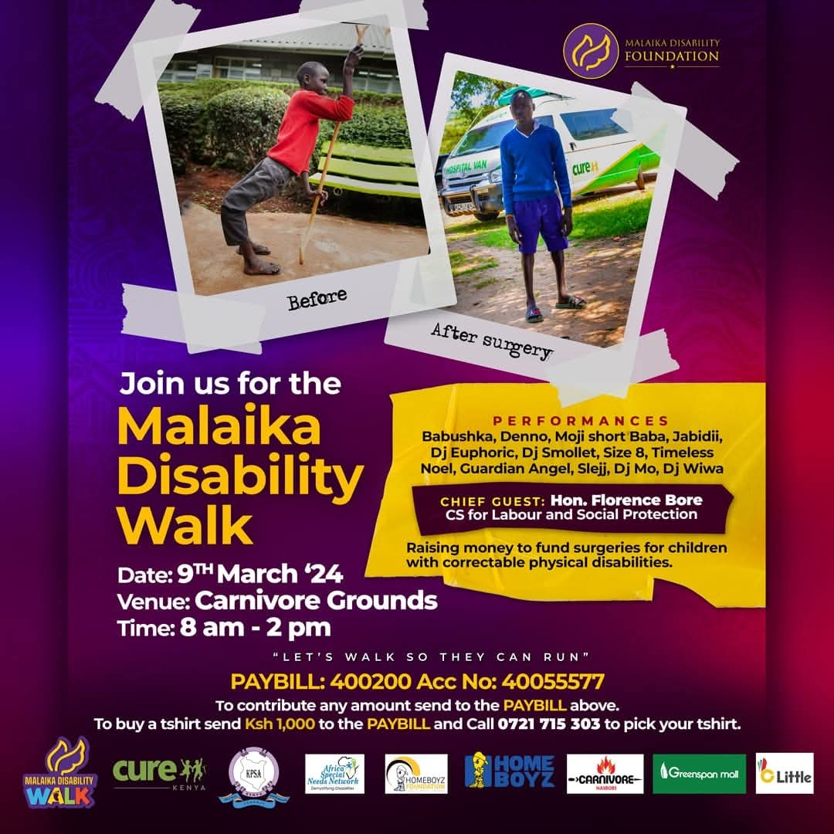
ASNEN’s work in 2024 emphasized collaboration, awareness, and the development of innovative solutions for inclusive education and support systems.

Introduction
Who We Are
The Africa Special Needs Education Network (ASNEN) is committed to advancing inclusion and equity for individuals with special needs across Africa. Our mission is to create awareness, build capacity, and foster collaboration among stakeholders to drive positive change.
Our 2024 Goals
- Expand awareness and understanding of neurodiversity through education.
- Foster partnerships with key organizations and stakeholders by attending workshops and seminars.
- Improve access to resources for children with disabilities and their caregivers through training.

Key Highlights of 2024
1. Webinars and Educational Initiatives
ASNEN in partnership with Bliss Navigator organized a series of impactful webinars aimed at increasing awareness and understanding of neurodiversity and special needs education:
Month | Topic | Moderator | Participants | Key Takeaways
February | Understanding the Power of Neurodiversity | Junietta Kanga | 120 | Highlighted neurodivergent strengths and advocacy.
March | Rare Diseases and Disorders | Faith Njahira Wangari | 80 | Explored rare conditions and disability inclusion.
April | Amplifying African Autistic Adults’ Voices | Junietta Kanga | 100 | Shared personal journeys and systemic barriers.
May | Social-Emotional-Psychological Health | Eva Nyoike | 70 | Addressed mental health in neurodivergent individuals.
June | Neuroscience Perspective on Brain Differences | Junietta Kanga | 64 | Explained the science behind neurodivergence.
July | Introduction to Learning Differences | Eva Nyoike | 88 | Discussed inclusive education strategies.
September | Dyslexia, Dyscalculia, Dysgraphia, Dyspraxia | Linda Gakuru, Eva Nyoike | 80 | Practical tools for supporting learning differences.
October | Celebrating Holidays with Neurodivergent Children | Junietta Kanga | 95 | Offered tips for inclusive holiday celebrations.
November | Financial Planning for Neurodivergent Children | Eva Nyoike | 95 | Addressed financial and legal planning for families.

2. Workshops and Advocacy Efforts
NESSP Workshop
With invitation from Action for Children with Disabilities, ASNEN participated in the 2023-2027 National Education Sector Strategic Plan (NESSP) workshop. Key outcomes included:
- Developing a roadmap for integrating Special Needs Education (SNE) into Kenya’s education framework.
- priorities like teacher training, infrastructure, and inclusive policies.
- Equipping stakeholders with tools for budget advocacy and policymaking.
APHRC Workshop
Organized by the African Population and Health Research Centre (APHRC), this workshop focused on the inclusion and development of individuals with disabilities in Kenya. It provided a platform to:
- Present preliminary findings from ongoing disability-related research.
- Gather feedback on the needs and proposed interventions for persons with disabilities.
- Build a technical working group to support disability research and initiatives.
- Identify priority areas where more evidence is needed to inform policy and practice.
Highlighted projects included:
- Special Needs Education Study: Assessing the implementation of Kenya’s 2018 Sector Policy for Learners with Disabilities.
- Adolescents with Disabilities Sexuality Study: Exploring sexuality education needs for adolescents with intellectual disabilities.
- Autism in Kenya Study: Examining educational services and caregiver support for children with autism.
- Neurodevelopmental Disabilities Study: Investigating nurturing care practices in rural Kenya.
The workshop brought together stakeholders from government, research institutions, and disability organizations, fostering collaboration and identifying funding avenues for further research.
Project Launch: Localizing Women’s Empowerment and Childcare in Kenya
This initiative, led by the Local Public Sector Alliance (LPSA) and Uthabiti Africa/Collaborative Action for Childcare (CAC), aimed to advance women’s economic empowerment (WEE) and childcare solutions. Key goals included:
- Formulating actionable policy proposals.
- Advocating for effective local-level WEE interventions.
- Promoting childcare solutions through enhanced multi-level governance.
Keynote Address: Dr. Joyce Mutinda, Chair of the National Gender and Equality Commission, highlighted the critical role of intergovernmental collaboration in WEE and childcare systems. Discussions focused on policy gaps, implementation challenges, and sustainable solutions.
3. Special Events
International Day of Persons with Disabilities
ASNEN participated in the International Day of Persons with Disabilities, an event dedicated to celebrating and advocating for the inclusion of persons with disabilities (PWDs) in all aspects of life. The 2024 event featured:
- Entertainment: Performances by various groups highlighting talents of PWDs.
- Key Speeches: Delivered by government representatives and NGOs, emphasizing the importance of inclusion in education, employment, and community life.
- Theme-Based Advocacy: Discussions focused on the 2024 theme, Amplifying the leadership of persons with disabilities for an inclusive and sustainable future. The leadership of persons with disabilities is epitomised by the global disability rights movement's slogan “Nothing About Us Without Us” underscoring the need for systemic changes to ensure PWDs are not left behind.

Community Impact
Success Stories
- Komolion Surgeries: Children like Kaspan Petel and Blessing Chepkorkor received life-changing surgeries, enabling them to reintegrate into school and community life.
- Webinar Testimonials: Participants reported increased understanding and actionable insights from the educational series.

Challenges Faced
- Limited funding for expanding initiatives.
- Logistical challenges in reaching remote areas.
- Advocacy hurdles in securing stakeholder commitment.

Financial Overview
- Total Funds Raised:
- Allocation:
  - Webinars:
  - Workshops:
  - Community Outreach:
  - Administration:
  - Staff:
  - Transportation

Looking Ahead: 2025 Goals
- Expand the Dynamic Differences initiative to new regions.
- Increase the number of workshops and webinars by 20%.
- Secure new partnerships to support funding and advocacy efforts.
- Enhance the caregiver support framework.

Recognition and Acknowledgments
We extend our heartfelt gratitude to our partners, sponsors, and stakeholders whose contributions made 2024 a successful year for ASNEN. Special thanks to Bliss Navigator, Uthabiti Africa, Collaborative Action for Childcare, Action for Children with Disabilities, and other collaborators for their unwavering support.

Call to Action
As we look ahead to 2025, ASNEN invites continued support from partners and stakeholders. By working together, we can create a more inclusive society by:
- Supporting our advocacy and capacity-building initiatives.
- Partnering with us to fund community outreach programs.
- Sharing our mission to promote awareness and inclusion for individuals with special needs.

Appendices
- Online seminar agendas and participant lists.
- Photos from events.
- Detailed financial breakdowns.

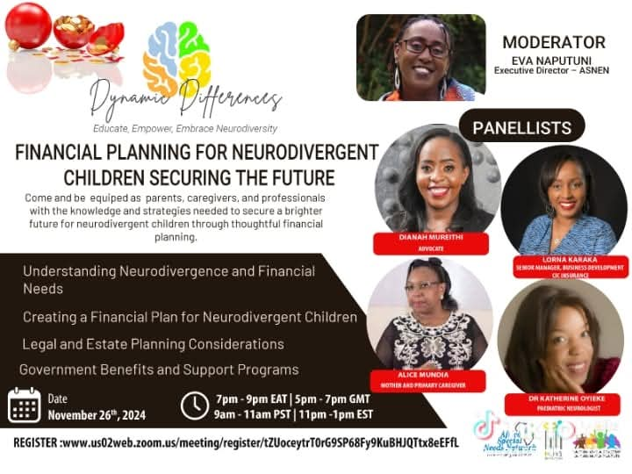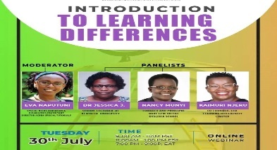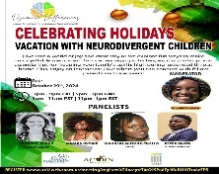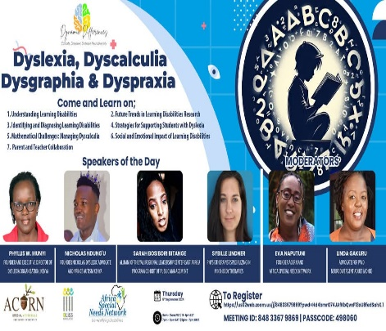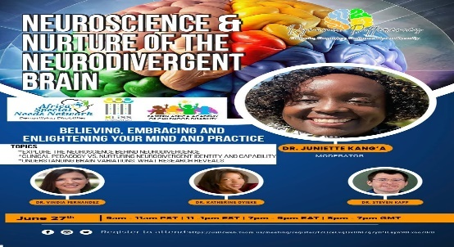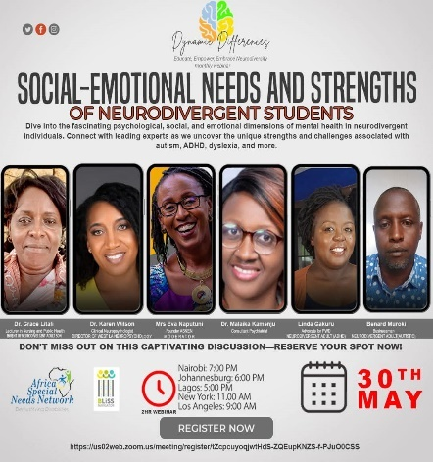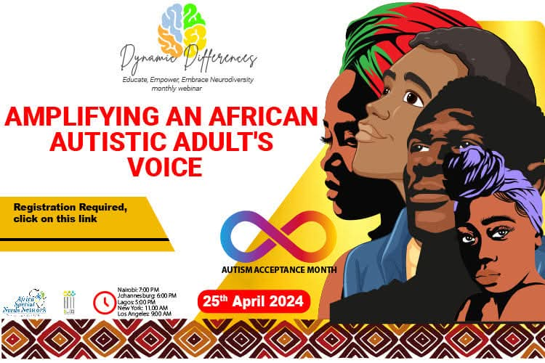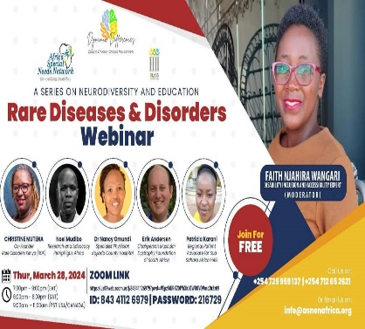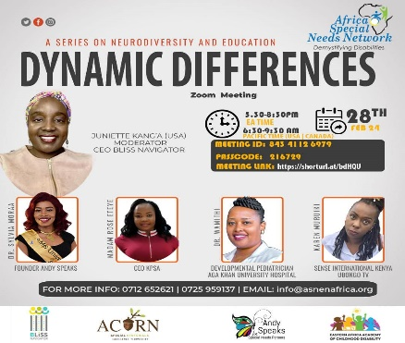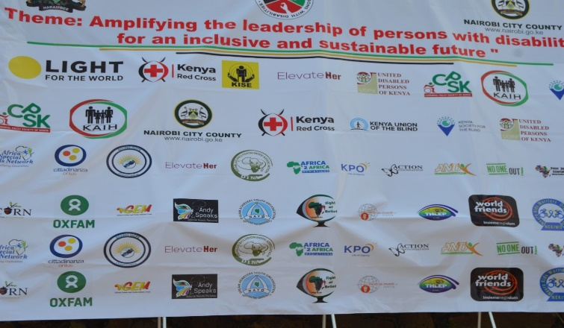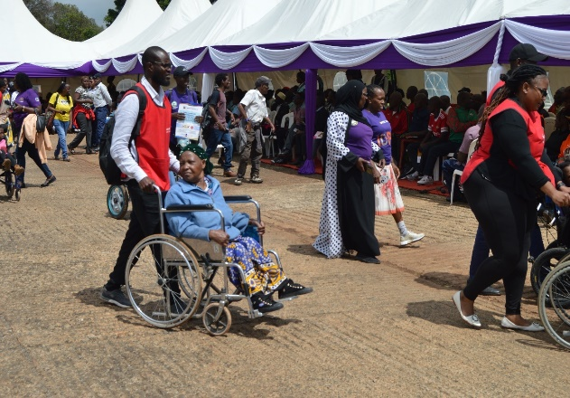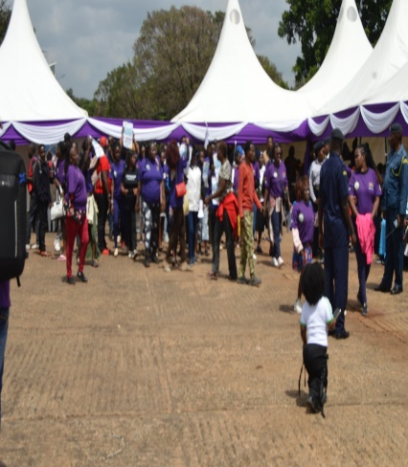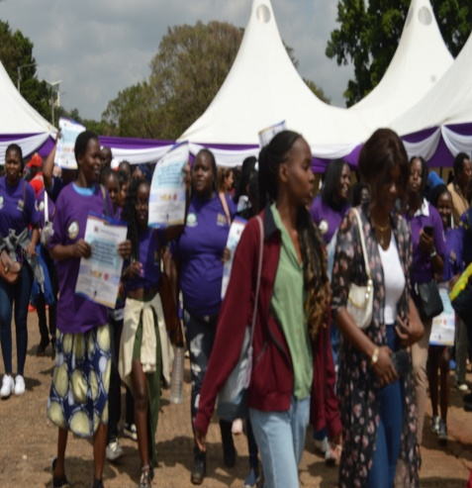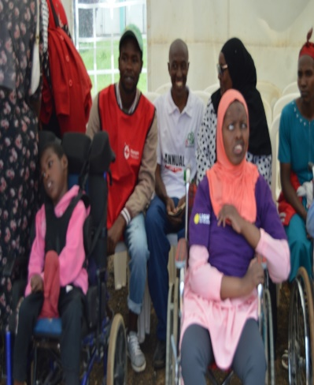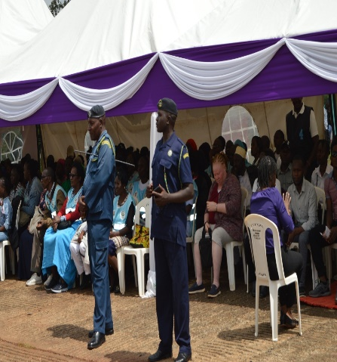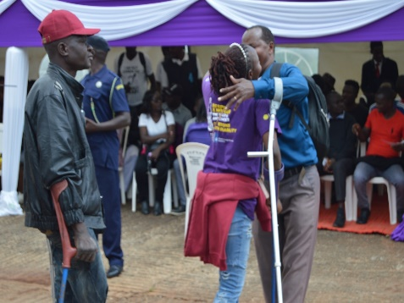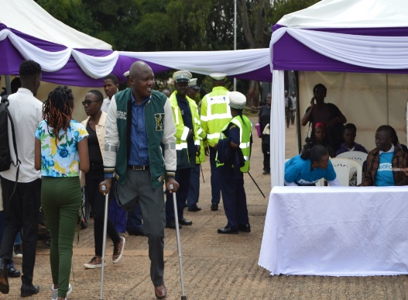3